

Website: <https://www.pickaboo.com/>

Types of Testing

## [Different types of testing are discussed

## and shown using example of this website]

# **Table of Contents**

|  |  |  |
| --- | --- | --- |
| SI | Description | Page Number |
| 1. | Black box testing | 1 |
| 2. | White box testing |  |
| 3. | Unit testing |  |
| 4. | Integration testing |  |
| 5. | System testing |  |
| 6. | Functional testing |  |
| 7. | End to end testing |  |
| 8. | Sanity testing |  |
| 9. | Smoke testing |  |
| 10. | Regression testing |  |
| 11. | User Acceptance testing |  |
| 12. | Load testing |  |
| 13. | Stress testing |  |
| 14. | Performance testing |  |
| 15. | Usability testing |  |
| 16. | Cross-Browser testing |  |
| 17. | Monkey Testing |  |

Testing Types

1.Black box /Behavioral /Data-driven/Closed box testing

It is a software testing method where functionalities of software applications are tested without having knowledge of internal code structure, implementation details and internal paths. It mainly focuses on inputs and outputs of software applications and it is entirely based on software requirements and specifications.

Tests are based on requirement and functionality; no internal system design is needed in this type of testing. The tests are tested on the perspective of end user.

Tools: functional and regression tests (Selenium, QTP), non-functional tests (LoadRunner, Jmeter)

**Pickaboo website checking search button**

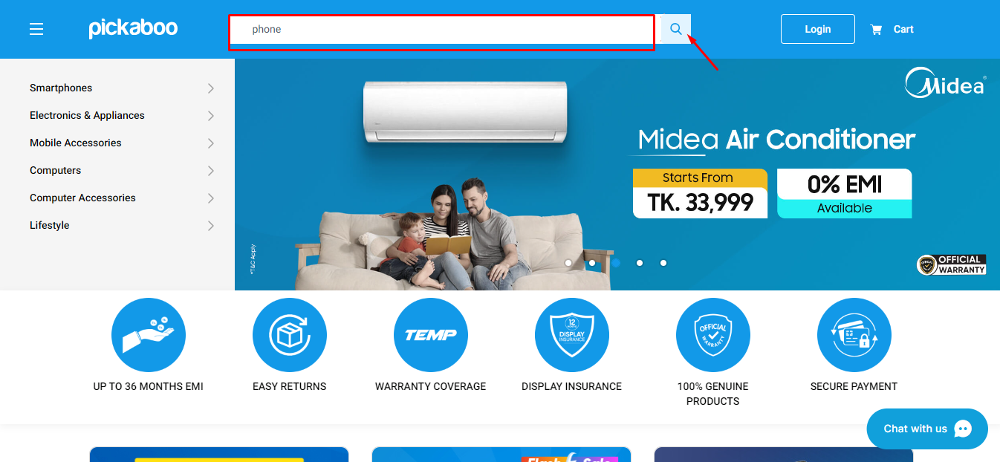

**Result after clicking search button**

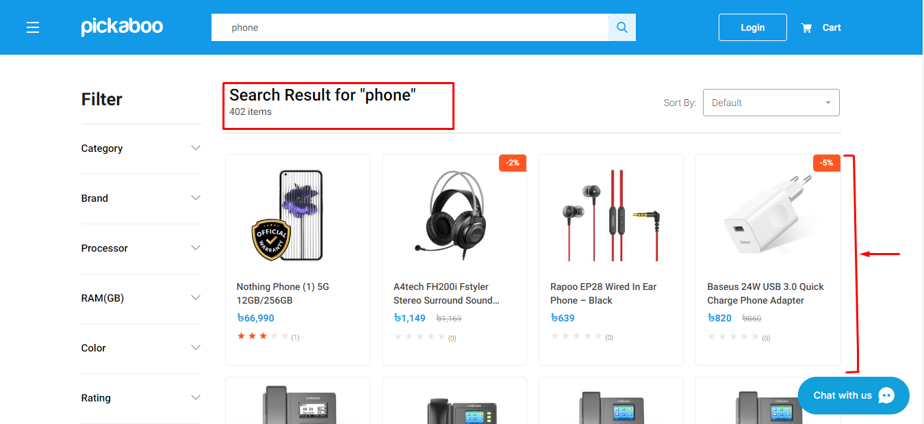

**Clicking the dropdown Button to work properly or not**

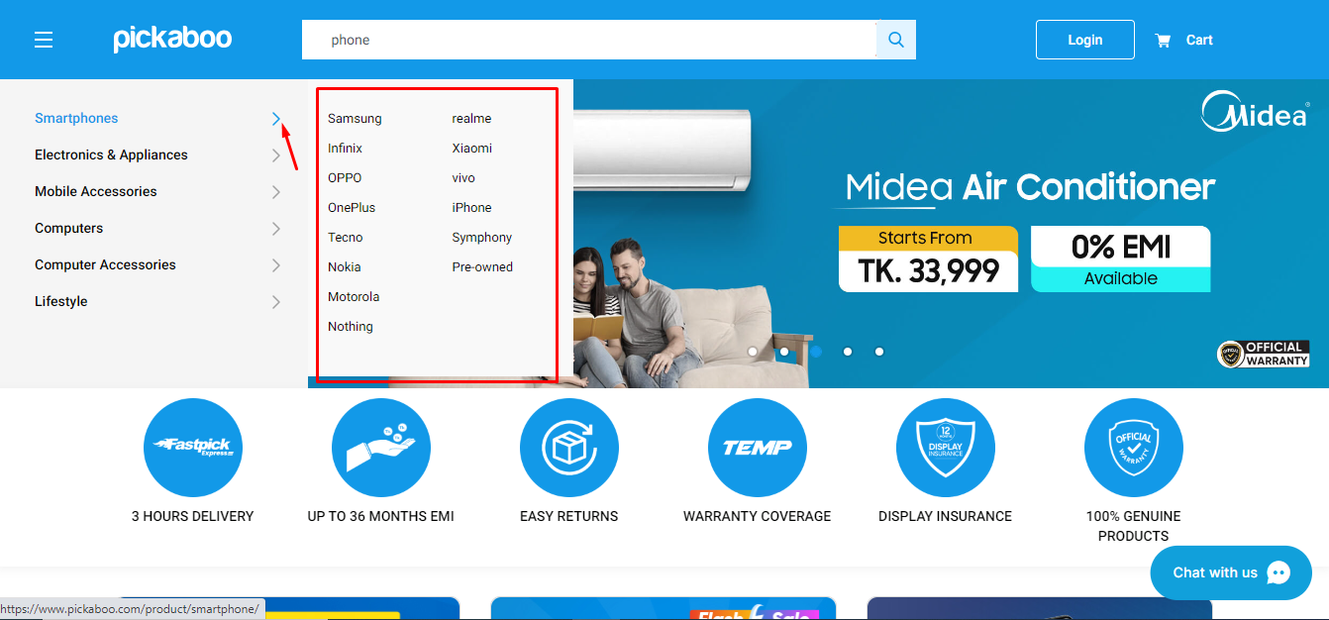 

2.White box testing /Glass box testing/Clear box/Open box/Transparent box/Code-based /Structural testing

It is a testing where software internal structure, design and coding are tested to verify input output flow and improve design, usability and security. White box can be applied to unit, integration and system level of testing process. Most intensively used in unit level.

It is the opposite of black box testing. It is based on the inner workings of an application and revolves around internal testing.

In the example clicking the fungi image all the codes behind that are given and if any bugs were found in that image the bugs can be reported from the code also.

Tools: Veracode, CppUnit, Nunit, RCUNIT.

**Pickaboo website Samsung page is given**

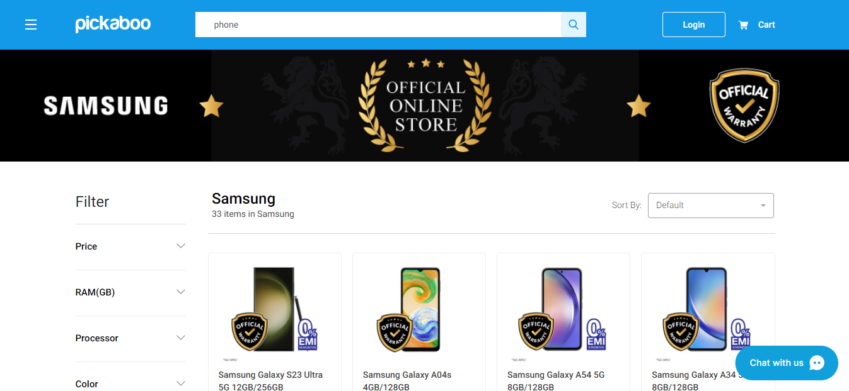

**Samsung webpage behind the coding is given where putting values in the code inspecting the output whitebox testing can be done.**

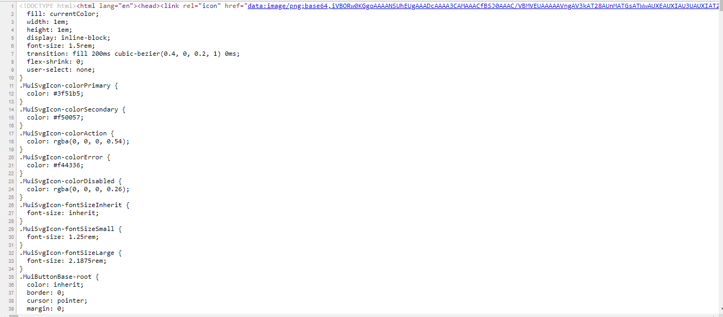

3.Unit testing

Testing of individual software module that requires knowledge of internal structure, design and code that are done by the developer not the testers.

4.Integration testing

This testing type testing integrated software modules to verify combine functionality after integration. Modules can be code modules, different application etc.

Generally, integration testing is performed after unit testing and before system testing.

It can be white boxed or black boxed testing.

Tools: Jenkins, Selenium, JUnit.

**Suppose we have register functionality**

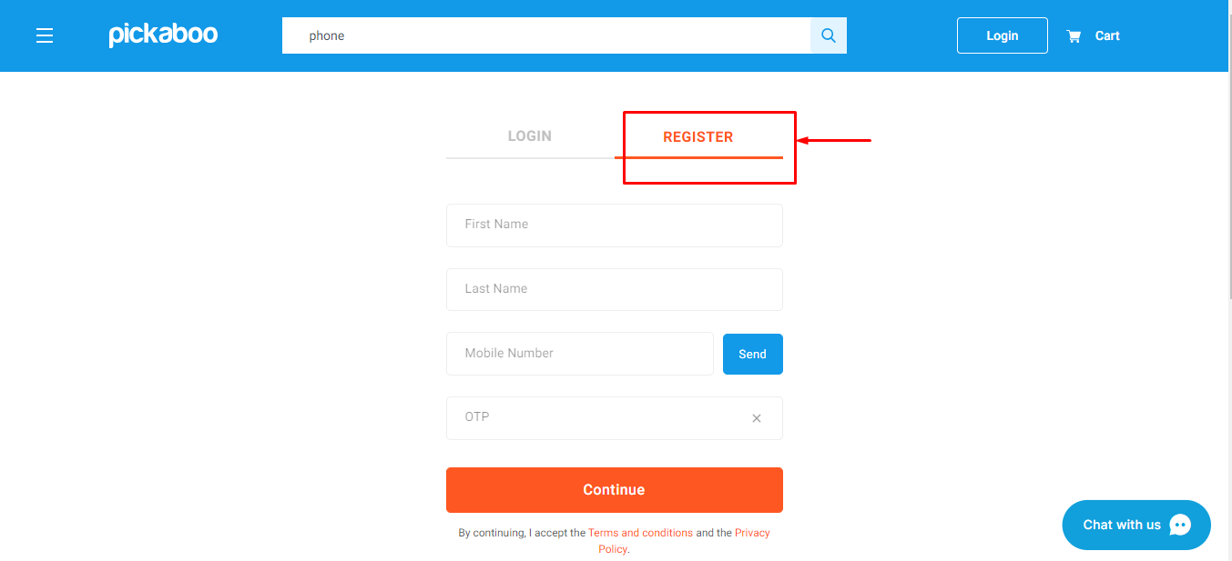

**now we add login functionality**



**Integrate both login and register functionality and then test**

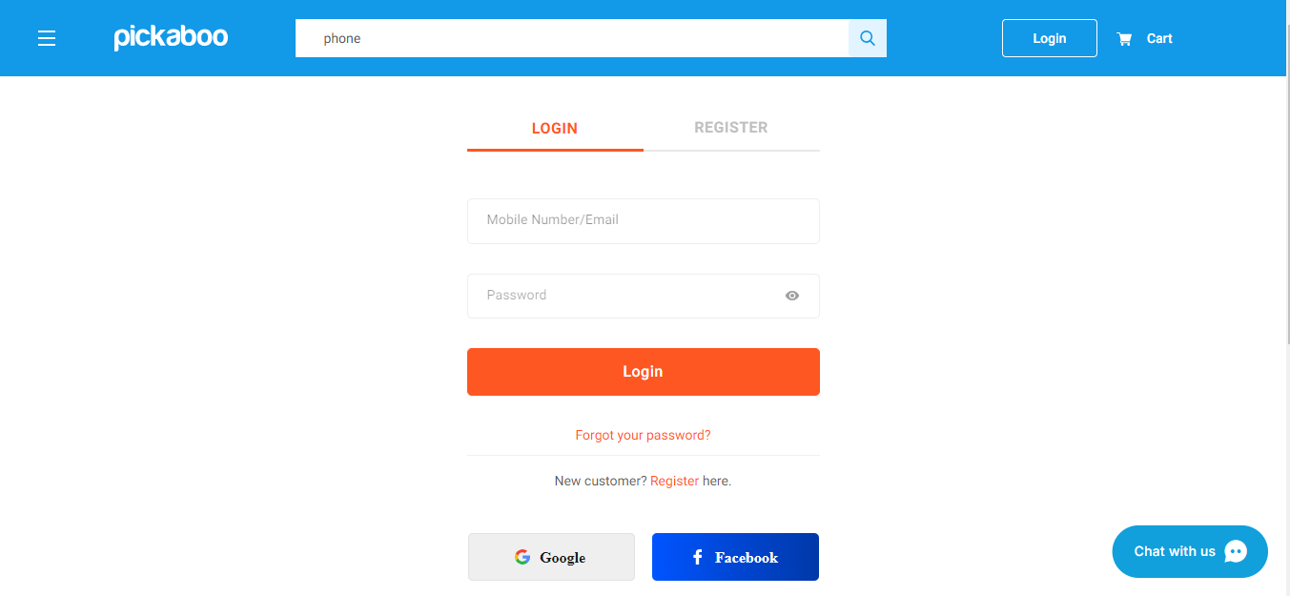

5.System testing

Entire system is tested as per the requirements. System testing is a type of software testing that is based on a whole complete system and covers all combined part of a system. It is a testing of a system inside the fully integrated software product. It is a type of black box testing.

There are 4 stages of software testing. Unit-integration-system-acceptance. There are more than 50 type of system testing. Among them usability, regression, functional, load, migration, hardware/software, recovery testing are more popular.

Tools: Selenium

**Complete website test**

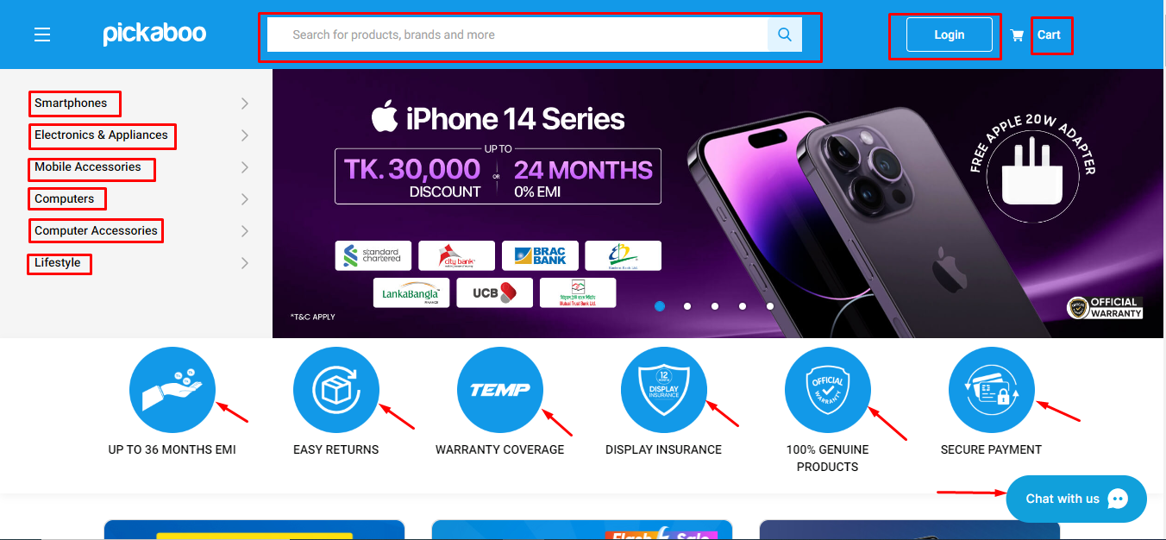

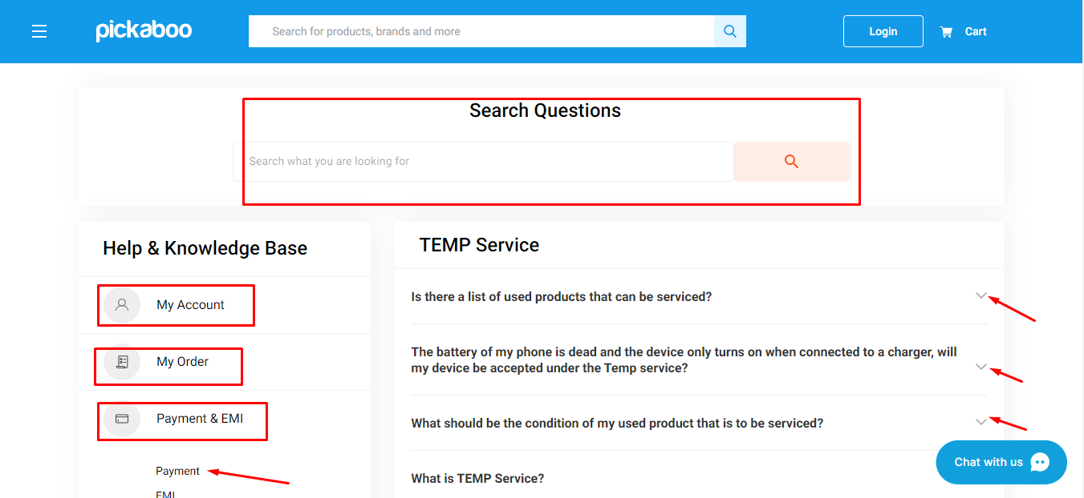

6.Functional testing

It is a type of testing which checks all the functionality of all the modules of software is working properly or not according to the software specification requirement. It ignores the internal part and focuses on the output part as per the requirement or not. It is type or child of black box testing and it can either be done manually or using automation. Functionality testing checks UI, APIs, database, security, client/server communication and other functionality of the application under test.

Tools: Selenium, SoapUI, QTP, JUnit.

**Search button or filter properly showing result or not**

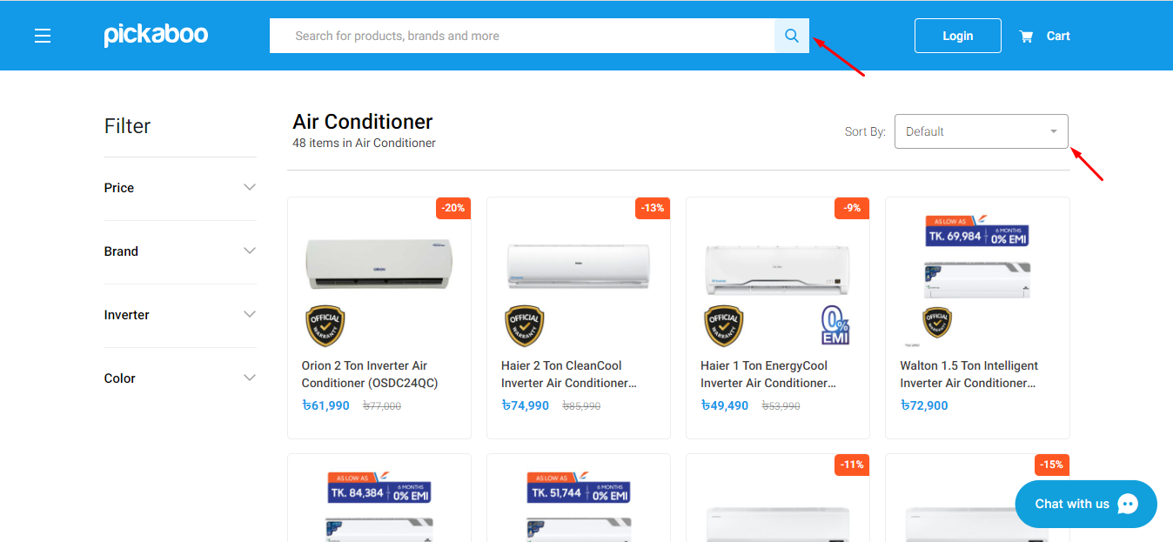

7.End to end/E2E/Chain testing

End to end testing involves testing of a complete software application from start to finish involving all the database, all the hardware, systems etc. of the total application is built upon. This testing method gives a complete end to end testing of the full software product.

Tools: testRigor

**Testing everything on the fully completed pickaboo website**

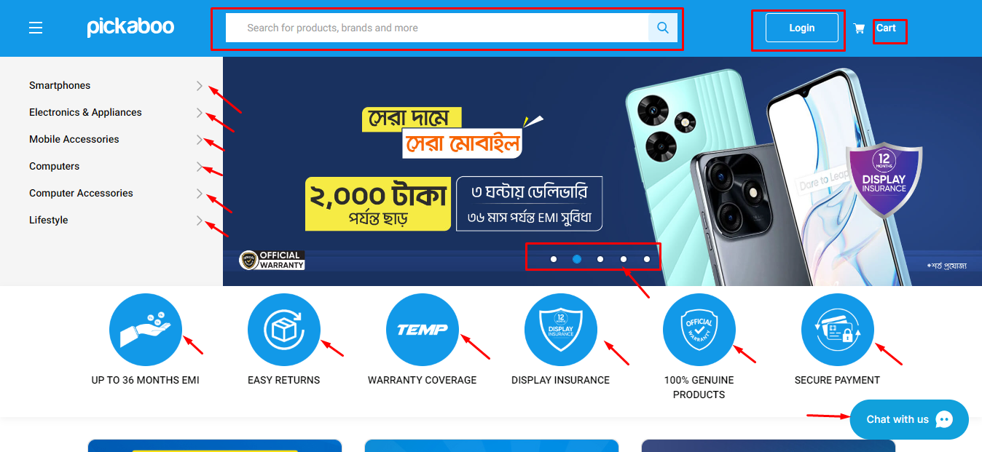

**Testing the whole integrated complete pickaboo android application**

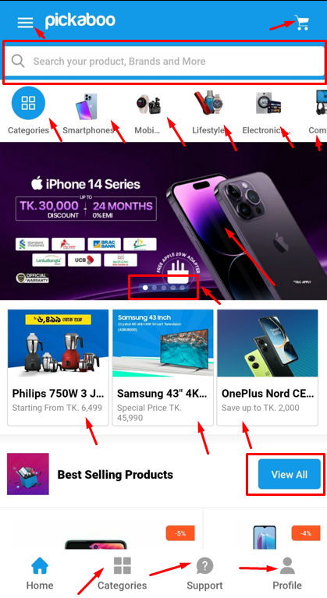

8.Sanity testing

Sanity testing is use to determine if a new software version is performing well enough to accept it for a major testing effort. If application is started to crash for the initial use then QA can’t proceed further to test and the application is assigned to fix. Sanity testing is used to check the new functionality or bugs have been fixed or not. It is a subset of regression testing. Sanity testing is not documented and also unscripted.

**In pickaboo major bugs was not found to perform sanity testing.**

9.Smoke/build verification/confusion testing

Smoke testing is a testing method which checks the core functionality of a software product. When a new functionality is developed and integrated to the existing software build that is deployed to QA/staging environment, smoke testing is done on the build to check the critical functionality is properly working or not. It is a small type of rapid and mini regression testing for core functionality and can be done both manually and with automation. Smoke testing is done to check the software is ready to do further testing or not. It is a subset of acceptance testing.

Sanity testing

Code

Unit testing

Integration testing

Smoke testing

Functional testing

**Checking core functionality such as login on pickaboo**

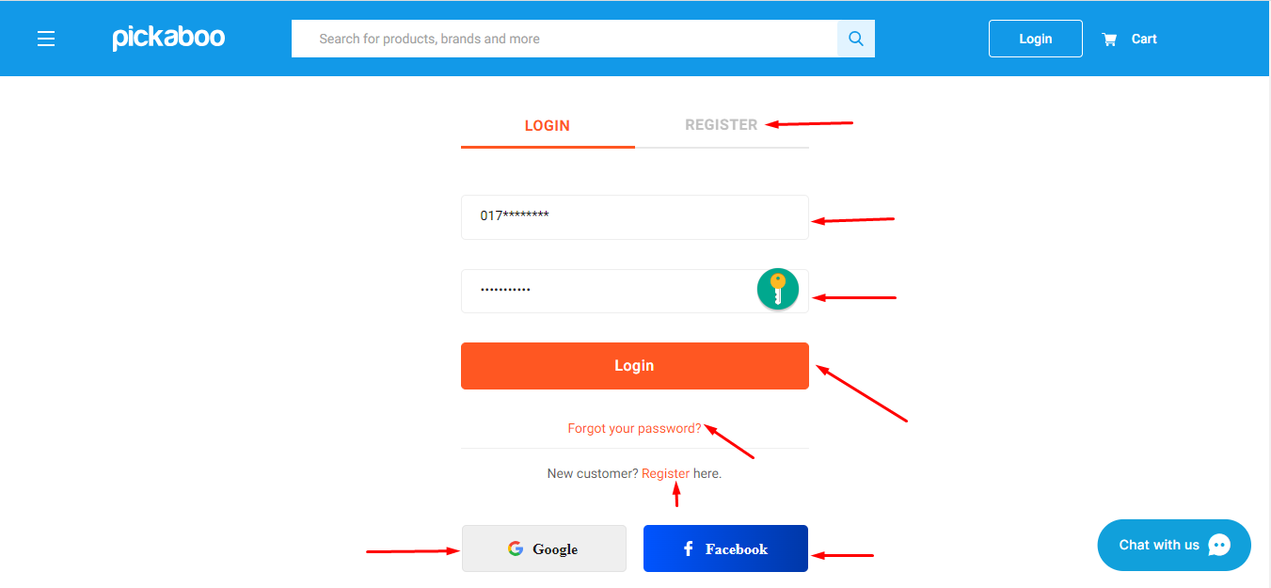

10.Regression testing

This testing method happens when a program has been updated in the software and to check the updated version doesn’t impact the existing part, regression testing is done. This testing basically checked the updated version and also checks the existing version from end to end point so that any changes couldn’t affect the software. This testing is done to ensure that new code changes don’t have side effects on the existing functionalities. It ensures that old code still works once the latest code changes are done.

Tools: Selenium, QTP, testRigor, Avo Assure, Subject7 etc.

**In pickaboo website if Lifestyle module is added we have to test the module.**

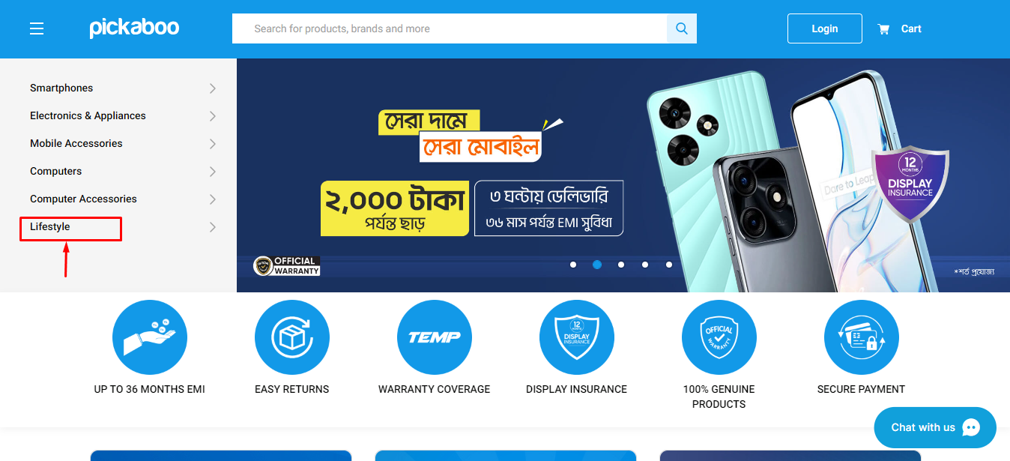

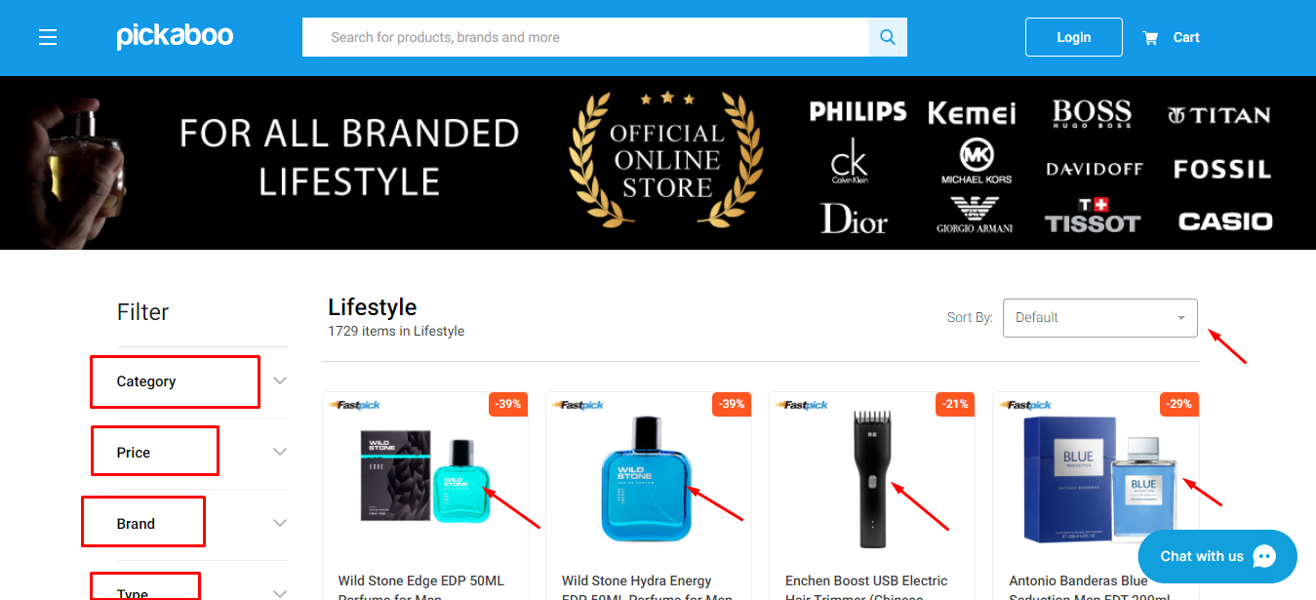

**For adding Lifestyle module Smartphones, Electronics and Appliances, Mobile Accessories, Computers, Computer Accessories all the other modules must be tested from end to end to ensure that newly added Lifestyle module doesn’t impact all the other modules.**

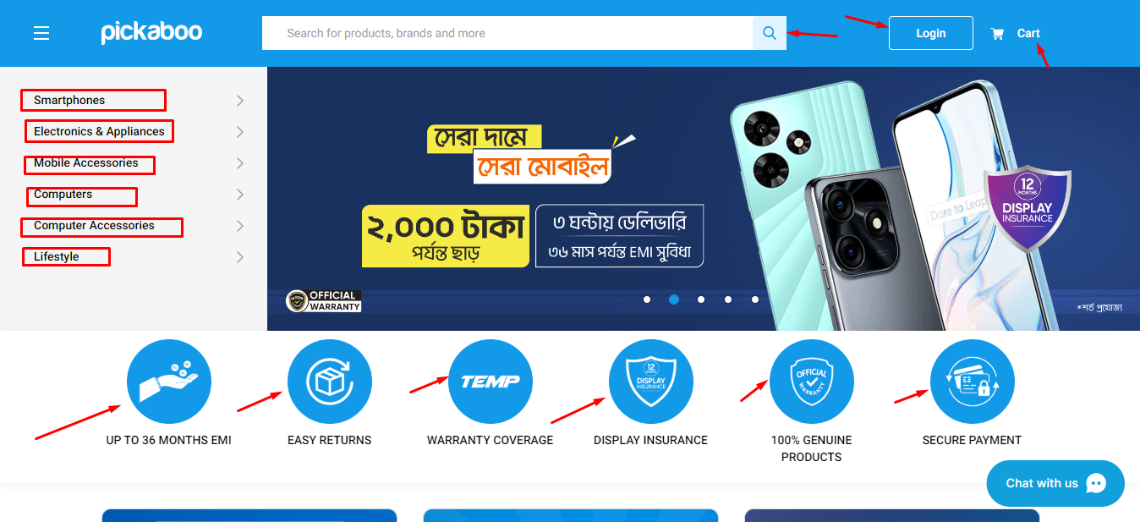

11.User Acceptance testing (UAT)/application testing

UAT is a type of software testing that is done by the client or end user to check or verify if the application is properly working or not according to the requirements before moving the software application to the production environment. It is tested in the last phase of testing. It is a type of black box testing. UAT is basically done by the clients.

12.Load testing

**Load Testing**is a non-functional software testing process in which the performance of software application is tested under a specific expected load. It determines how the software application behaves while being accessed by multiple users simultaneously. Load testing is defined as a type of software testing that determines a system’s performance under real-life load conditions. It is a performance testing that checks the system behavior under heavy load. In load testing load limit is a threshold of a break.

Tools: LoadNinja, Load Runner

**Pickaboo website multiple users trying to open this page**

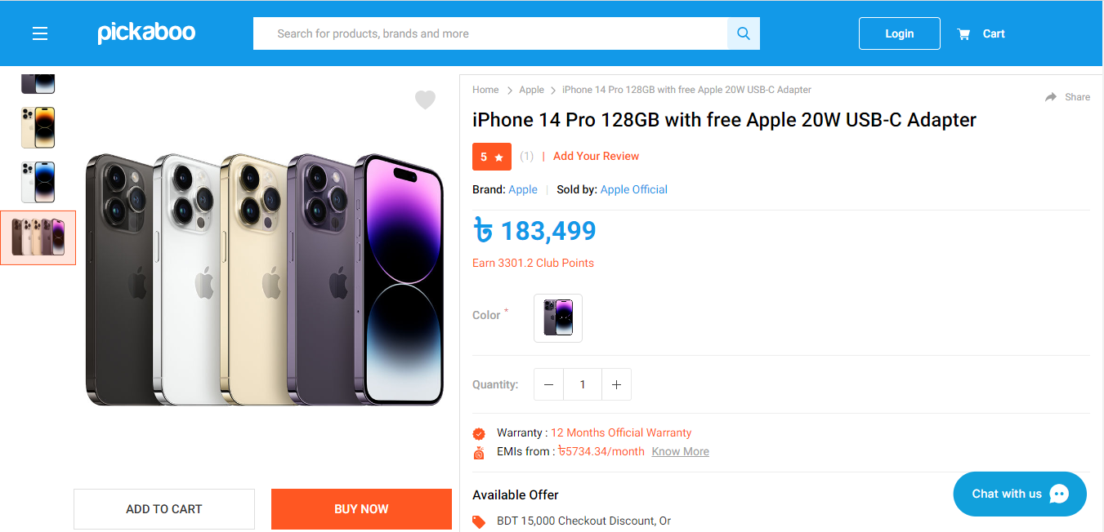

13.Stress/Negative/Endurance/Under stress testing

Stress testing is a testing method where system is stressed beyond its specification to check how and when the system fails. It is a subset of performance testing. In stress testing load limit is above the threshold of a break. The goal of this testing is to find a breaking point where system crashes and that’s why unfavorable situation is created to stressed the system to see when it breaks. It is also a non-functional testing technique. The goal of stress testing is to analyze the behavior of the system after a failure. For stress testing to be successful, a system should display an appropriate error message while it is under extreme conditions. The main purpose of stress testing is to make sure that the system recovers after failure which is called as **recoverability.**

Tools: Jmeter, Stress Tester, Neo load

**In pickaboo website register module is tested in unfavourable condition and beyond it’s specification.**

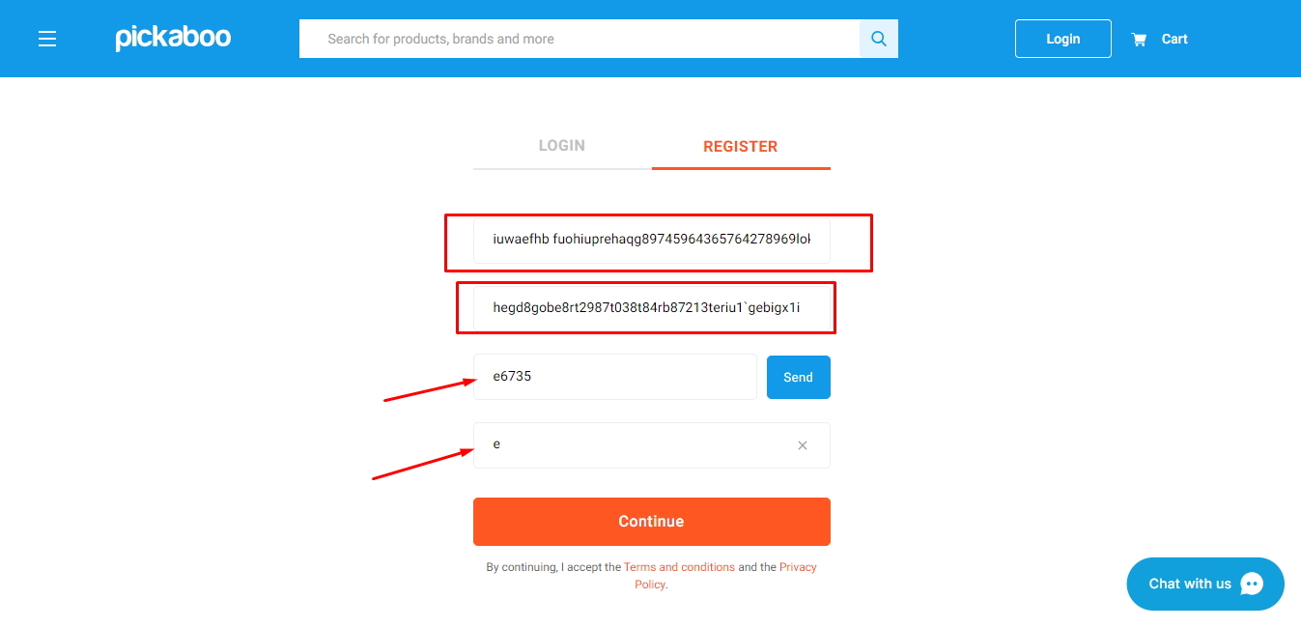

14.Performance testing

Performance testing is a software testing process to check the overall performance of a software application on how it is performing.It is a testing process to check the system meets performance requirements. It is a superset of load and stress testing. In performance testing load limit is both below and above the threshold of a break.

Tools: Jmeter, LoadNinja, HP LoadRunner, HeadSpin

**To check performance of main function, stress, load and time**

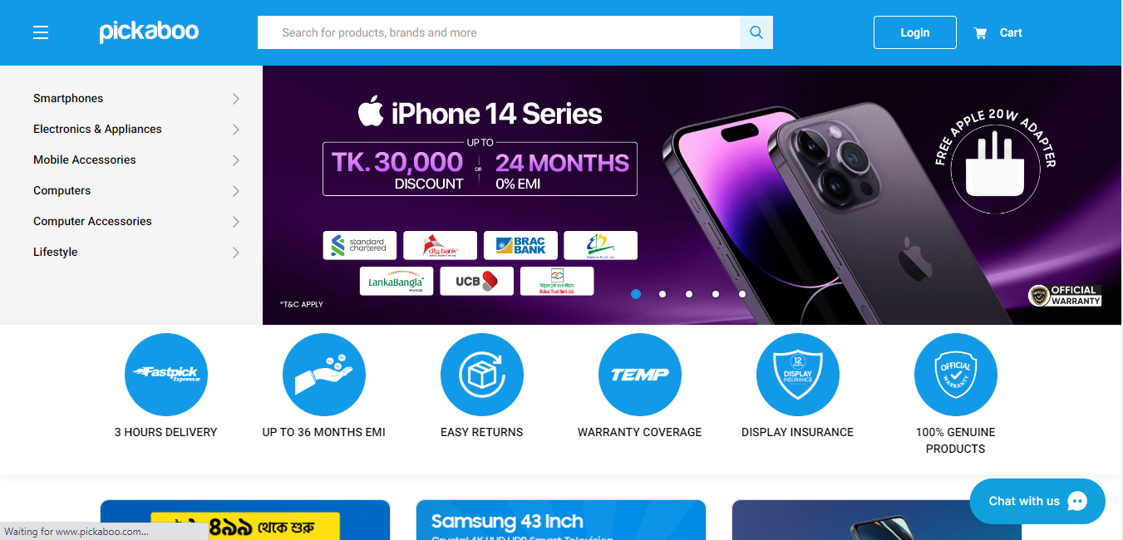

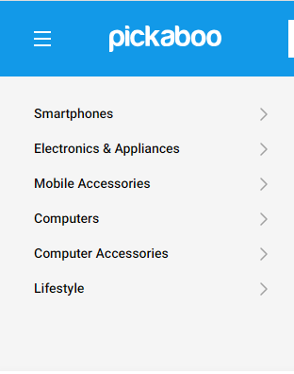

**Taking time to load the next page**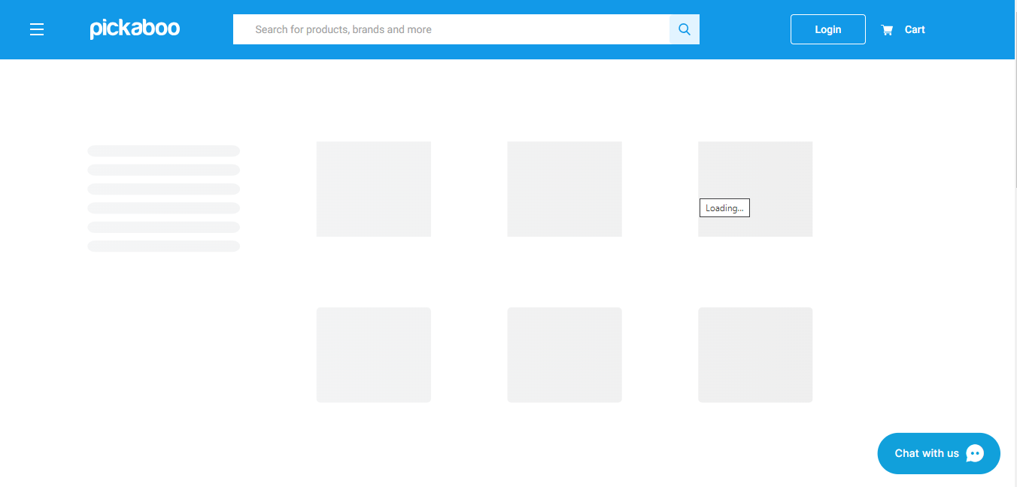

15.Usability testing

Usability testing is a testing method for measuring how easy and user-friendly a software application is. It’s purpose is to how user feel ease to use the software application.

**In pickaboo, these below examples make the website more user friendly.**



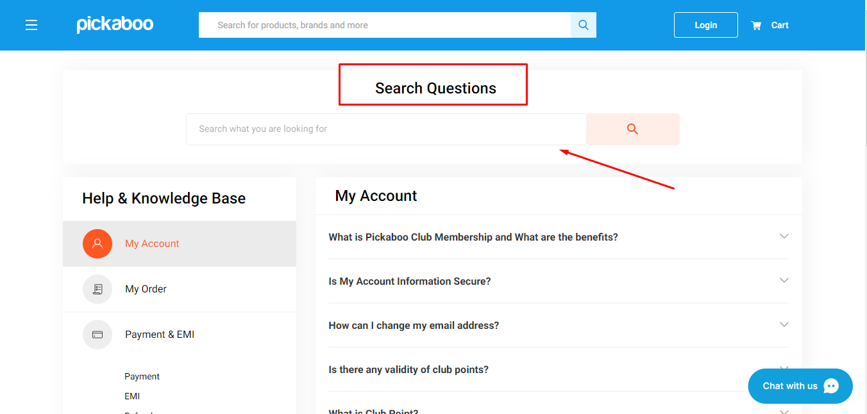

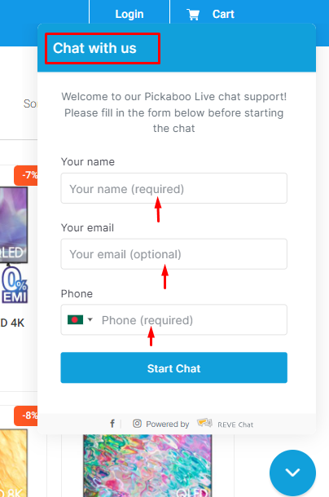

16.Cross-Browser testing

**Cross Browser Testing** is a type of functional test to check that your web application works as expected in different browsers.

Browser compatibility testing on different browsers

-Firefox

-Google Chrome

-Microsoft Edge etc.

**Microsoft Edge**

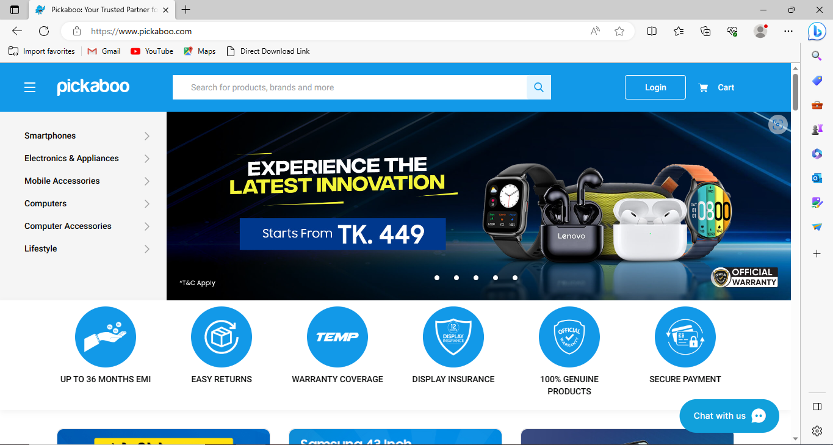

**Google Chrome**

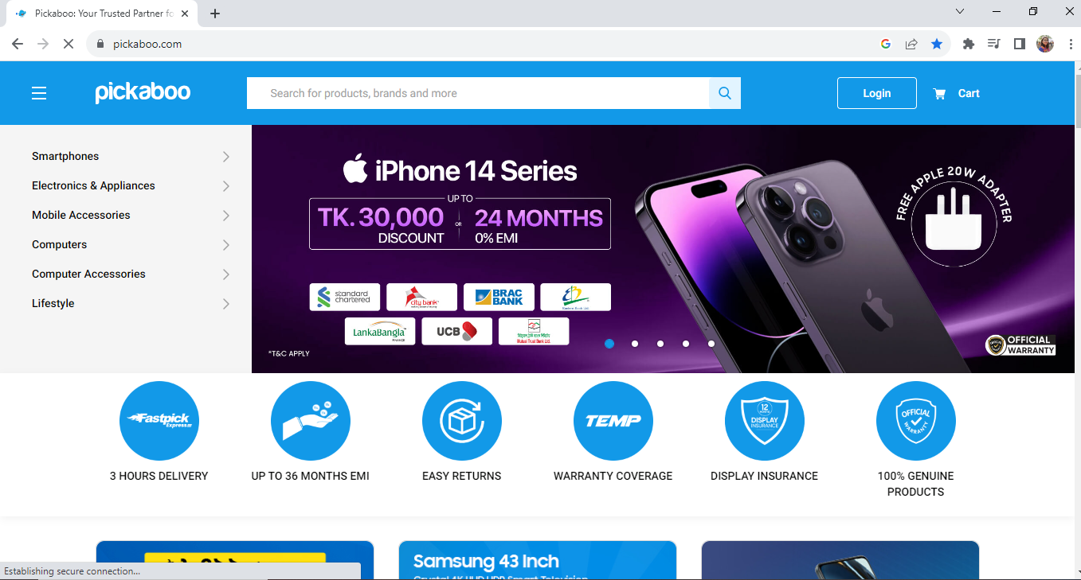

17.Monkey testing

**Monkey Testing**is a software testing technique in which the tester enters any random inputs into the software application without predefined test cases and checks the behavior of the software application, whether it crashes or not. The purpose of Monkey testing is to find the bugs and errors in the software application using experimental techniques.

**Jumping from home page to television**



